Ideation Phase

Define the Problem Statements

|  |  |
| --- | --- |
| Date | 31 January 2025 |
| Team ID | LTVIP2025TMID50416 |
| Project Name | Heritage Treasures: An In-Depth Analysis of UNESCO World Heritage Sites in Tableau |
| Maximum Marks | 2 Marks |

**Customer Problem Statement Template:**

Create a problem statement to understand your customer's point of view. The Customer Problem Statement template helps you focus on what matters to create experiences people will love.

A well-articulated customer problem statement allows you and your team to find the ideal solution for the challenges your customers face. Throughout the process, you’ll also be able to empathize with your customers, which helps you better understand how they perceive your product or service.

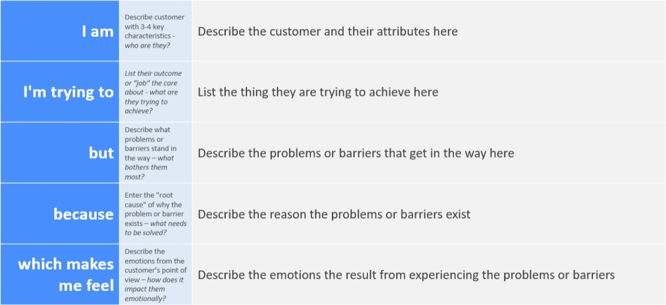

Reference: <https://miro.com/templates/customer-problem-statement/>

**Example:**

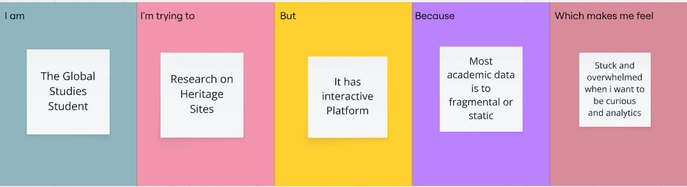

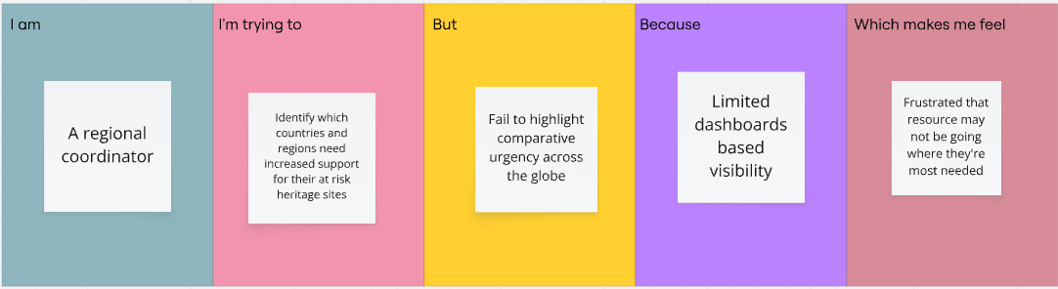

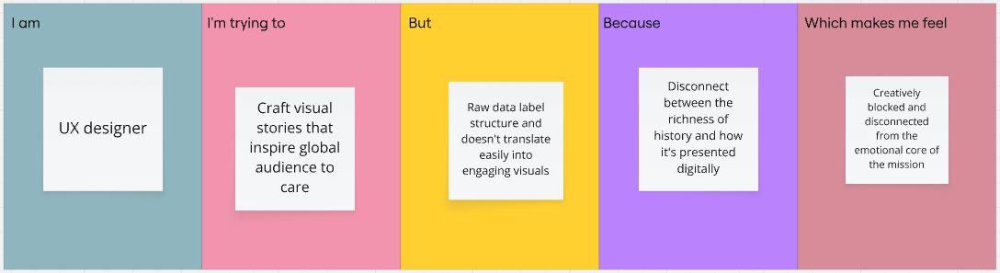

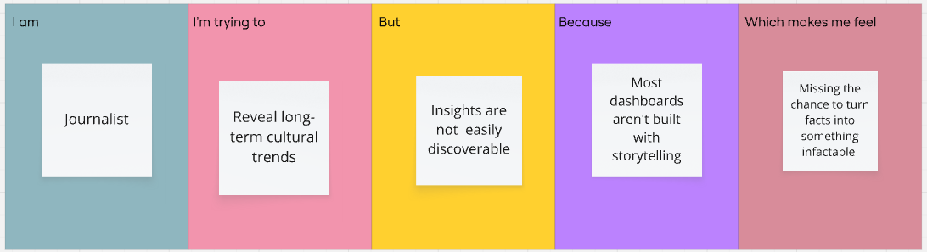

|  |  |  |  |  |  |
| --- | --- | --- | --- | --- | --- |
| **Problem**  **Statement (PS)** | **I am (Customer)** | **I’m trying to** | **But** | **Because** | **Which makes me feel** |
| PS-1 | The Global Studies Student | Research on Heritage sites | It has interactive Platform | Most academic data is to fragmented or static | Stuck and overwhelmed when i want to be curious and analytics |
| PS-2 | A regional coordinator | Identify which countries and regions need increased support for their at risk- heritage sites | Fail to highlight comparative urgency across the globe. | Limited dashboards-based visibility | Frustrated that resource may not be going where they’re most needed. |
| PS-3 | UX designer | Craft visual stories  That inspire global audience to care | Raw data lacks structure and doesn’t translate easily into engaging visuals | Disconnect between the richness of history and how it’s presented digitally. | Creatively blocked and disconnected from the emotional core of the mission |
| PS-4 | Journalist | Reveal long-term cultural trends | Insights aren’t easily discoverable | Most dashboards aren’t built with storytelling | Missing the chance to turn facts into something impactful |